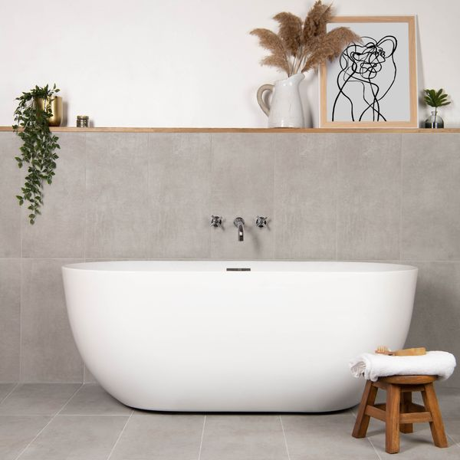**Scultura Grigio Stone Effect Tiles:**

## **Product Description**

Create a calm, natural look in your home with our Scultura Grigio Stone Effect Tiles. Designed in a soft light grey hue, these tiles feature a riven surface with a windswept look that adds depth and movement to the interiors of your home. Made from durable, hardwearing porcelain, they have an anti-slip surface with a natural matt finish.

**What’s special about these tiles?**

> Soft, natural look

> Durable, hardwearing porcelain body

> Riven surface design

> Easy to clean and maintain

## **Product Info**

* Product ID: 45704
* Tiles Per SQM: 5.6115463177033
* Sale by: Per SQM
* Size: 298x598x8mm
* Weight: 3.30 KG
* Material Type: Porcelain
* Finish: Matt
* Colour: Grey
* Suitability: Floors, Walls
* Area Of Usage: Internal
* Grade: 4
* Rectified Edge: No
* Underfloor Heating: Yes
* Anti Slip Grade: R10 / 19-27 Degrees
* Thickness (mm): 8